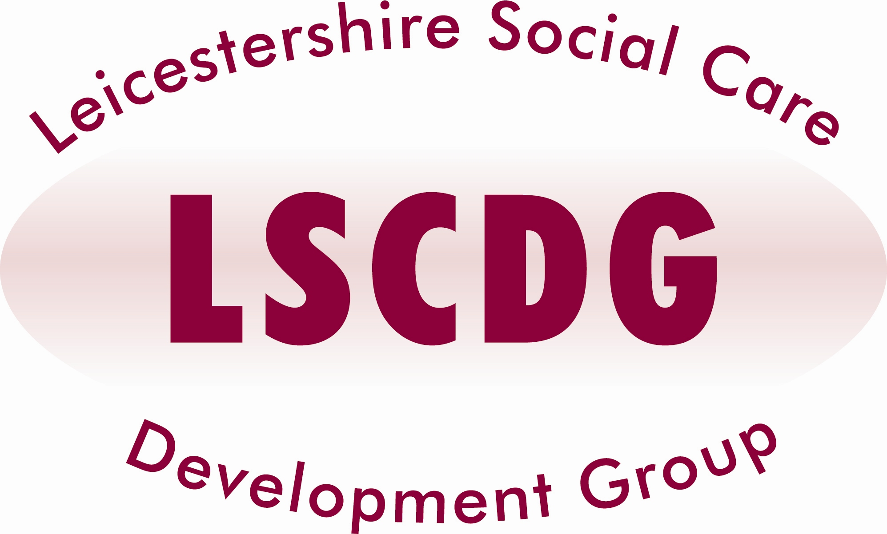

Communication Awareness - £30 per delegate

AIMS and OBJECTIVES:

- Communicating well with people who have communication difficulties.
- Overcoming barriers to communication
- Using and understanding nonverbal communication in the context of total communication

TARGET GROUP:

- All staff who come into contact with people with learning disabilities.

Dates and venues available

Dates available | Venues
04.12.14 | Salvation Army, South Wigston

Times:
Arrive 9.15 for registration and refreshments for a 9.30am start and finish 4.30pm

Refreshments will be provided. Lunch will NOT be provided

With effect from April 2014, LSCDG will be implementing changes in the business process, for the forthcoming training programme for 2014 - 2015.

For this course care providers will be invoiced at a flat rate of £30 per delegate, after the attendance.

If delegates fail to attend, the establishment will be invoiced for the non-attendance rate of £100 (if the course is more than a day then this will be £100 per day).

Local Authority staff will be required to enter a COST CODE on the booking form, in the event of non-attendance your Department will be invoiced, therefore authorisation from your manager is required for you to attend this training.

VISIT OUR NEW WEBSITE

www.lscdg.org

Click on the ‘Training Events’ tab, scroll down to choose the Course and Date you wish to attend.

From here you will be able to check availability and book yourself on the training.

