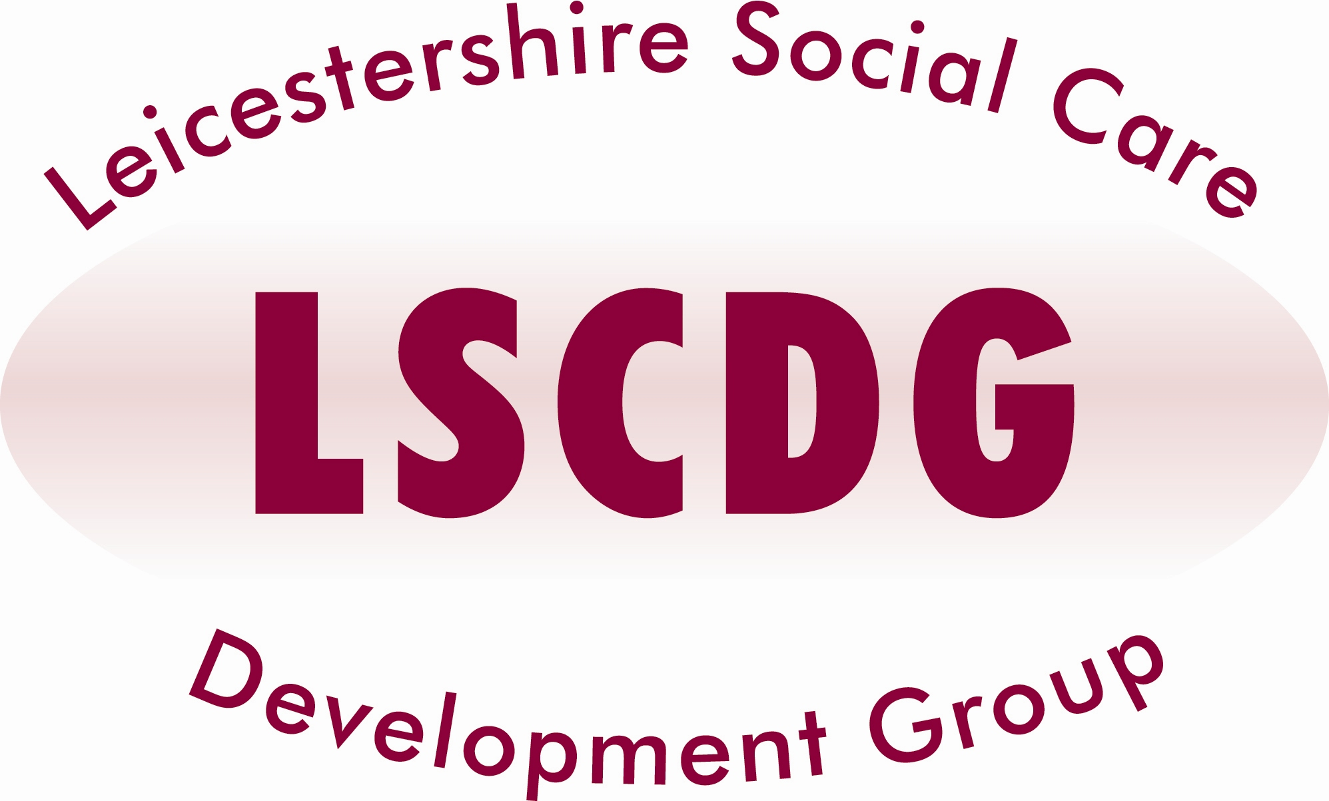
A Beginner’s Guide to
Autism Spectrum Disorder
(3 Hour Workshop)

What does receiving a diagnosis of ASD mean?
What are the “Autistic Traits” and how do they impact people’s lives?
What does the future hold for a person with this condition?

Target Group:

Our free workshop is specifically designed to answer these and other questions for anyone with a new interest in the subject (e.g., recently diagnosed / family / support network). Informal and interactive discussions, led by an individual diagnosed with ASD, provide insight into the realities of living with the condition.

Refreshments will be provided. Lunch will NOT be provided

Dates available: | Venue: | Time:
29th January 2016 | Green Towers, Hinckley Club for young people, Hinckley | 10am – 1pm
5th February 2016 | NSPCC, Leicester | 2pm – 5pm
15th March 2016 | Heartwood Conferencing Ltd, Coalville | 6pm - 9pm

VISIT OUR WEBSITE www.lscdg.org

Click on the ‘Training Events’ tab, select the course from the drop down CATEGORY, and click on the magnifier. Scroll down and find the date you require.
Click on the DETAILS AND MAP button.
Check availability. If places are available, scroll down to find the booking form, fill in and submit. You will receive an acknowledgement.
If your nomination is approved then a confirmation will be sent 2 weeks before the training date.

LSCDG Contact:
Hansa Kanji on 0116 30 57438
Sabina Sidat on 0116 30 55185
(Email: LSCDG@leics.gov.uk)

