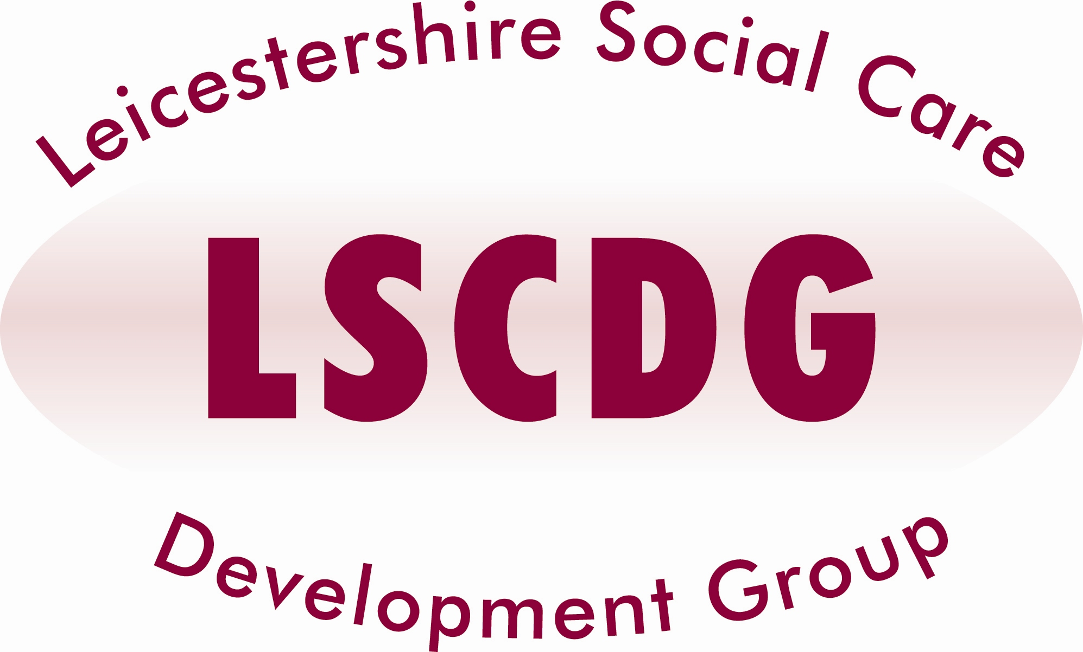
Dementia Category C
(Two day course)
Multi-Agency (Fully Funded)

AIMS and OBJECTIVES:
- Introduce learners to the theory of Kitwoods Enriched Model of Dementia Care. Then using this as a framework, translate the theory into practice to enable services to use a truly person centred approach, which puts the person not the disease at the centre of the provision.
- To consider the meaning behind behaviour and identify how communication can support the maintenance of personhood.
- To develop an action plan for improvement both at an individual and service level

TARGET GROUP:

Designed for staff who are both passionate and committed about providing high quality compassionate care from diagnosis to end of life, whilst working with people living with dementia.

Delegates must attend both dates. Day 1 followed by Day 2.

Dates available | Venues
21/06/16 & 21/07/16 | The Salvation Army, South Wigston

Course Times:
Arrive 9.00am for a 9:30 start and finish 4.00pm

Refreshments will be provided. Lunch will NOT be provided

This course is a multi-agency training and will remain fully funded, therefore you will only be charged, if delegates fail to attend. The establishment will be invoiced for the non-attendance rate of £100 per person.

Local Authority staff will be required to enter a COST CODE on the booking form, in the event of non-attendance your Department will be invoiced, therefore authorisation from your manager is required for you to attend this training.

VISIT OUR NEW WEBSITE - www.lscdg.org

Click on the ‘Training Events’ tab, select the course from the drop down CATEGORY, and click on the magnifier. Scroll down and find the date you require.
Click on the DETAILS AND MAP button.
Check availability. If places are available, scroll down to find the booking form, fill in and submit.
You will receive an acknowledgement.
If your nomination is approved then a confirmation will be sent 2 weeks before the training date.

The LSCDG Website is available till the 3rd June 2016.

We are launching a new Learning Management System (The Hub) on 6th June 2016, you will need to register for this to book on LSCDG courses. Please follow this link: http://www.lscdg.org/lms-information/

LSCDG Contact:
Hansa Kanji on 0116 30 57438
Sabina Sidat on 0116 30 55185
(Email: LSCDG@leics.gov.uk)

