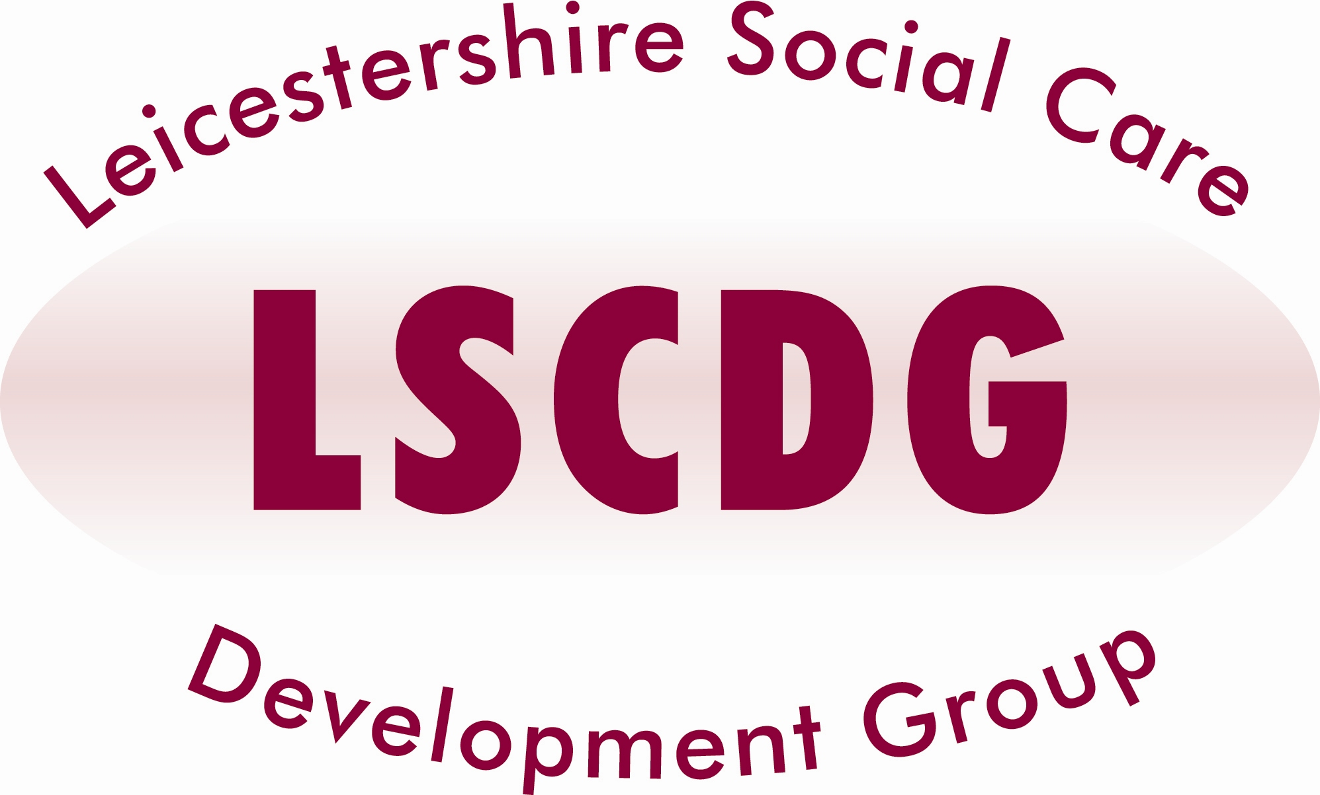
Communication Awareness
in Learning Disability

£30 per delegate

AIMS and OBJECTIVES:

- Communicating well with people who have communication difficulties.
- Overcoming barriers to communication
- Using and understanding nonverbal communication in the context of total communication

TARGET GROUP:

- All staff who come into contact with people with learning disabilities.

Dates and venues available

Dates and venues available | Venue
28th October 2016 | NSPCC Leicester

Times:
Arrive 9.15 for registration and refreshments for a 9.30am start and finish 4.30pm

Refreshments will be provided. Lunch will NOT be provided

For this course care providers will be invoiced at a flat rate of £30 per delegate, after the attendance.

If delegates fail to attend, the establishment will be invoiced for the non-attendance rate of £100 per person.

Local Authority staff will be required to enter a COST CODE on the booking form, in the event of non-attendance your Department will be invoiced, therefore authorisation from your manager is required for you to attend this training.

The new Learning Management System (The Hub) is now live, you will need to register and create an account should you wish to book on LSCDG courses.
Please follow this link: http://www.lscdg.org/lms-information/

Visit our website - www.lscdg.org
For further information relating to the LSCDG, courses and the Learning Management System
LSCDG Contact:
0116 30 57438
Email: LSCDG@leics.gov.uk

