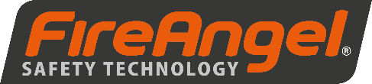
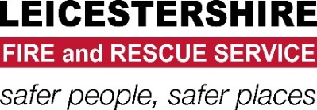

“Awareness Session - January”

Leicestershire Fire and Rescue Service (LFRS) are working with Air Liquide and FireAngel to offer FREE training to anyone who provides a service in the home of a vulnerable person in the LLR area.

Who is the session aimed at?
- Organisations from across the public, voluntary and community and private sectors that come into contact with vulnerable members of our community.
- Anybody that works within the home of a vulnerable person that could better from an increase in fire protection.
- Anyone who provides a service in the home of an oxygen user.

Learning Outcomes:
- Have a better understanding of the risks associated with Oxygen within the home.
- Have a better understanding of the products that FireAngel offer
- Increase your awareness of fire safety in the home and the referral process into LFRS.

Where?
Peter Roffey Suite, Leicestershire Fire and Rescue Service Headquarters, Geoff Monk Way, Birstall, LE4 3BU

When:
0900 - 1300 Hrs on January 21st 2019

How to book your space or for more information:
Email Community.Safety@LFRS.org stating…
- Your name and organisation that you are representing
- Your preferred date

Dave George
Community Safety

