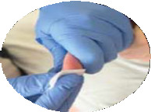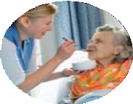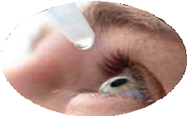

**Leicester, Leicestershire and Rutland**

**Health and Social Care**

**E-Learning Launch**

**2nd August 2018**



**How to access e-learning**

To book on any LSCDG courses you need to access The Hub, If you have an account please login using the below link;

https://leicestershiretotara.learningpool.com/login/index.php

If you do not have an account, you will need to create an account ,for each member of staff. Staff will not be able to book or complete e-learning without access to account. To facilitate the creation of the accounts LSCDG can help you with this. Please use the template attached, LSCDG will use this information to create the user accounts, you only need to this once.

After completing the template please email to [lscdg@leics.gov.uk](mailto:lscdg@leics.gov.uk) Once your account has been set up you will be notified of the username and password Further information can be found on the website <http://www.lscdg.org/lms-information/>

Any queries about The Hub should be emailed to [lscdg@leics.gov.uk](mailto:lscdg@leics.gov.uk)

**WHAT WE ARE OFFERING?**

A new programme for the Health and Social Care Protocol has been developed that consists of 6 e-learning modules and assessment workshops. The 6 modules are: Introduction, Pressure Ulcer Care, Nutrition and Hydration, Medication, Stoma Care and Blood Sugar Test.

The e-learning programme provides the knowledge of the delegated tasks that are needed to acquire the passport for HSCP Generic Tasks. This programme is only available on the LSCDG Learning Hub - see below on how to access the Hub. The e-learning modules must be completed within 4 weeks; you are then required to attend assessment 1 and 2. workshops within three months. Please book a time slot to complete both assessment days. Failure to compete both in the allocated time will result in you having to retake the e-learning and assessments modules again.

Any queries regarding the HSCP please contact [janet.taylor@leicspart.nhs.uk](mailto:janet.taylor@leicspart.nhs.uk) or 07917550583

It is recommended that you complete the module in Epilepsy although this is not currently included in the Health and Social care Protocol. If you have already commenced the face to face HSCP training there is no need to complete e-learning also.