How to find the status of a LCC Supplier
This guidance document walks you through the steps for finding the supplier status using the Procure to Pay dashboard in Oracle. This is the fastest way to establish if the supplier is set up and does not require you to raise a ticket with the FSC to find out.
On your Oracle home page select the Tools menu and click the Report and Analytics app…
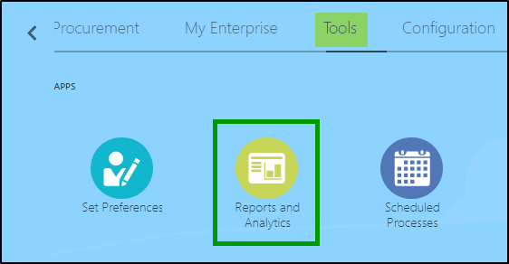
From the Reports and Analytics page select Browse Catalogue in the top right hand corner…
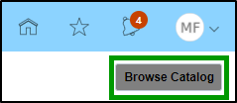
You will navigate to the Oracle Transactional Business Intelligence (OTBI) reporting tool where you can select the Dashboards drop down menu and then select Procure to Pay Dashboard…
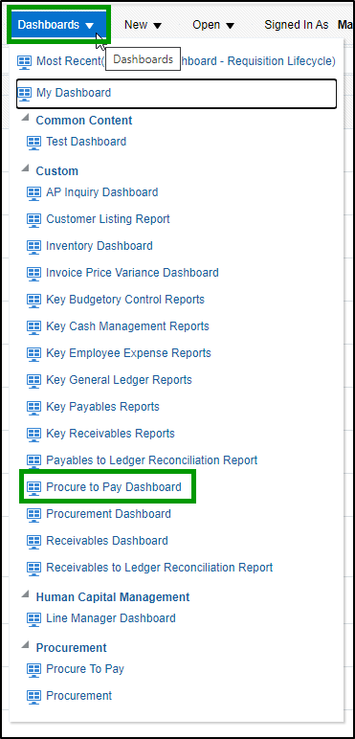If you cannot access the Procure to Pay dashboard, please contact Technical.AccountingTeam@leics.gov.uk who will review your Oracle roles.
Navigate to the Suppliers page and enter the prompt details for Primary Ledger, Business Unit, and the Supplier Name you want to search and then click Apply…
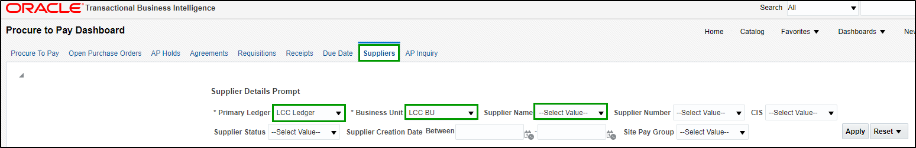
If the supplier exists in Oracle it will display the details relating to the supplier, including the supplier status (1) and the supplier site status (2). The supplier site address (3) is displayed and should correspond with the supplier you are ordering goods and services from…

FAQs
What do I need to do if the supplier name searched does not return data? or the supplier was active in the Old Oracle but is not appearing in the new Oracle?
This will be because the supplier is not currently registered as an LCC supplier or the supplier was made inactive when the data was migrated from the old Oracle. The FSC cleansed the supplier master data and suppliers who had not been transacted with for 14 months were not migrated. If a new supplier record is needed, you should request the supplier to complete the supplier registration form. You should also provide the link to the information contained on the supplier set up help page here to ensure the supplier has the guidance to support the registration. You may also check the supplier registration progress by reviewing the Supplier Registration dashboard (guidance on page 4 below).
How do I make a supplier whose status is showing as inactive, active again?
Suppliers showing the status ‘Inactive’ for the supplier header or a supplier site will need to be made active again before payment or purchasing can be made. The most efficient way is to contact the FSC via the EMSS portal. A supplier does not need to re-register if they or the requesting department are aware that they have previously been setup, a ticket detailing the supplier details along with the request for reactivation will suffice. EMSS may need to complete some additional verification checks before the supplier is made active. Further guidance can be found here.

How do I set up a supplier if the supplier is already set up for a partner organisation (e.g. Nottingham City Council)?
Where a supplier is setup for a partner organisation and needs to be set up for LCC, the supplier should re-register through the portal, as we require the registration and questionnaire details completing as part of the LCC procurement process. Once submitted EMSS will complete the relevant checks and add any new sites or contacts to the existing supplier, EMSS will then advise the supplier of our partnership with the other organisations and advise they have linked the LCC details to their existing account.
If a supplier receives a message to state that the bank details are already in use during the registration process, they should leave the bank account details in step 5 blank and add a note to say they are a current supplier for EMSS.
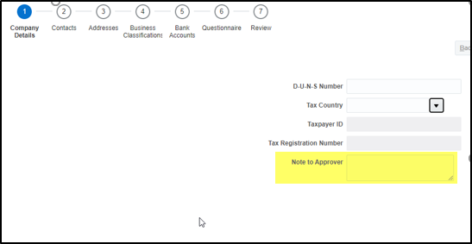

How to check the progress of the supplier registration
If the supplier is not appearing in the Supplier Details analytic, it may be due to the supplier’s registration still being in progress. You can search to see if the supplier has started the registration process and at what stage they are at.
On the Suppliers page enter the prompt details in the ‘Supplier Registration’ prompts for Inviting Procurement BU and Company.
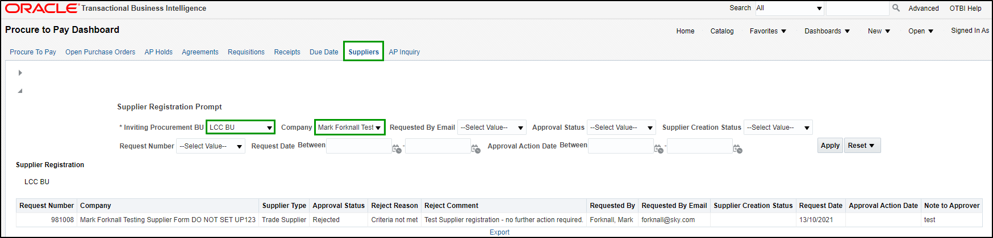
The status of the supplier registration will be displayed, and this will indicate where the supplier is in the process.
Approval Status | Meaning | Action
Approved | The supplier registration has been approved and the supplier has been added to the Oracle master data (note an approved supplier could still be made ‘inactive’) | Check the Supplier Details analytic for the supplier status and new supplier number.
Not Submitted | The supplier has not completed the registration. | Contact the supplier and ask them to complete the remaining steps of the registration.
Pending Approval | The supplier has submitted the registration request and is currently pending the counter fraud checks and Oracle set up. | If the request date is within the SLA, stay patient. If the SLA has passed you or your supplier can contact the FSC quoting the Request Number for further advice.
Rejected | EMSS FSC have rejected the request as the supplier has not met the requirements. | The report will display the rejection reason and comments that provides information for you to contact the supplier and request for this to be addressed.

For further help and guidance with the supplier set up process, please visit the links below.
LCC Intranet https://leics.sharepoint.com/sites/intranet/HDI/Pages/set-up-a-new-supplier.aspx
EMSS support portal, Freshdesk https://emss.freshdesk.com/support/home
P2P Community Yammer group https://web.yammer.com/main/groups/eyJfdHlwZSI6Ikdyb3VwIiwiaWQiOiI2OTY0MjM5NTY0OCJ9/all.

