Evidence of learning (Worksheet)

Standard 15: Infection prevention and control
15.1a: Describe the main ways an infection can get into the body.
15.1c: Explain how your own health or hygiene might pose a risk to the individuals you support or work with.

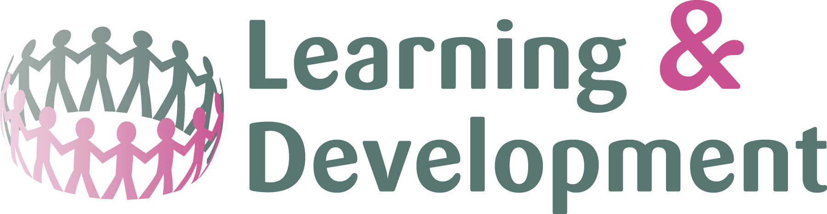

Signed: Assessor/Manager:………………………………………………… Date:………………………………………………………………………

Signed: Learner:…………………………………………………………………….. Date:………………………………………………………………………

